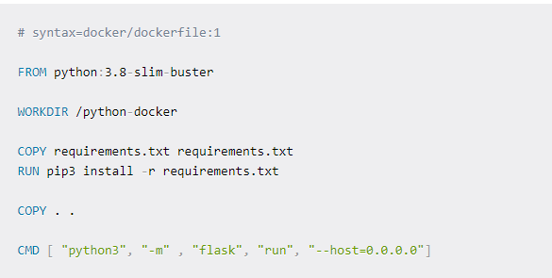

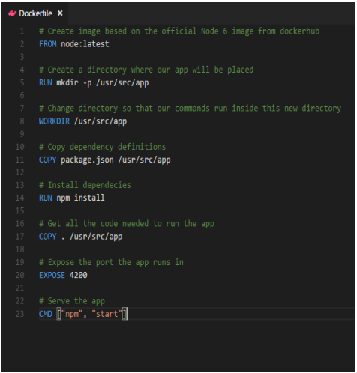

BMW Assignment Topics

|  |  |  |  |
| --- | --- | --- | --- |
| Roll No | Name | Docker Assignment | |
| 120A3043 | Salman Juber Adhikari | Study of Docker Compose | |
| 120A3017 | Jorapur Swati Vedavyasrao |
| 120A3024 | Kumbhare Kunal Rajesh |
| 120A3026 | Mayank Raj |
| 120A3013 | Gupta Chirag Santosh |
| 120A3059 | Upadhyay Shreyas Sudhakar |
| 120A3003 | Bhagwat Shubham Anand |
| 120A3021 | Koneti Madhurya |
| 120A3033 | Nishita Swaminathan |
| 120A3045 | Shah Drashti Sanjay |
| 120A3039 | Pravin Guruputhiran |
| 120A3053 | Shreyash Suhas Kadam |
| 120A3005 | Chaudhari Shivam Sunil | Study of Docker Networking | |
| 120A3038 | Pinjara Aman Arif |
| 221A3069 | Thevar Kanddakumaran Murugan |
| 120A3002 | Baital Sneha Sagar |
| 120A3009 | Dudhmal Parag Mahadev |
| 120A3015 | Iyer Tarun Kannanaresh |
| 120A3046 | Shaikh Mohammad Sahil Mohammad Salim |
| 120A3047 | Shelke Dhiraj Anil |
| 120A3049 | Shinde Rushikesh Dattatray |
| 221A3067 | Omkar Navnath Jamdar |
| 120A3001 | Asmi Nitin Sawant |
| 120A3008 | Dodake Ayush Suresh |
| 120A3011 | Ekhande Kirti Madhukar |
| 120A3022 | Kruti Upasani |
| 120A3023 | Kukadia Dhairya Suresh |
| 120A3030 | Nair Aditi Viswanathan |
| 120A3032 | Nashikkar Rohan Chandrashekhar |
| 120A3034 | Ojha Aniket Raghav |
| 120A3062 | Vedant Mahesh Bojjawar |
| 120A3014 | Harsh Pritam Koli |
| 120A3025 | Mali Himani Ajit |
| 120A3040 | Rai Ankur Rammohan |
| 120A3054 | Singh Anurag Sujeet Kumar |
| 221A3064 | Aayush Umashankar Singh |
| 120A3004 | Bhanushali Jay Mahendra |
| 120A3016 | Jagdale Yash Ajit |
| 120A3042 | Rao Ruchir Dinesh |
| 120A3051 | Shreya Sanjay Idate |
| 120A3019 | Kharat Saloni Ajit |
| 120A3027 | Mohammed Rafe Mohammed Zafer Shamsi |
| 120A3029 | Mulye Devang Anand |
| 120A3035 | Parakh Prakash Pawar |
| 120A3056 | Sonakshi Jha |
| 120A3010 | Dukare Vedika Babaji |
| 120A3020 | Konar Esakkiraja Esakkimuthu |
| 120A3044 | Sankpal Shubham Jitendra |
| 221A3068 | Soumya Sollinselvan Muthupushpam |
| 120A3018 | Khan Tanseer Aurangzeb Alam |
| 120A3036 | Patil Subodh Sanjay |
| 120A3060 | Vaibhavee Thakur |
| 118A3043 | Rauther Muskan Raj Mohammed |
| 120A3028 | Mohite Pratik Prakash |
| 120A3006 | Chhabra Ramanjit Singh Manmohan Singh |
| 120A3007 | Chinmay Devadiga |
| 120A3041 | Rai Bhoomi Prakash |
| 120A3050 | Shivani Pandeti |
| 120A3031 | Nanaware Pratham Suresh |
| 120A3063 | Yadav Aditya Ramashish |
| 221A3065 | Hinge Atharva Bhuleshwar |
| 120A3055 | Singh Sakshi Suresh |
| 120A3048 | Shetty Mohit Vidyanand | Study of Dockerfile Commands | |
| 120A3052 | Shreyas Prabhakar |
| 120A3061 | Varad Thorat |
| 120A3058 | Tandel Raj Nishikant |
| 120A3012 | Gaikwad Kirti Vikas |
| 120A3037 | Pavale Soham Harivijay |
| 221A3066 | Nadar Sathish Samuthira Muthu |
| 111A3023 | Kharat Amish |